**UID EXERCISE – 3**

This exercise is about using different types of user interface to rename a file.

The interfaces used in this exercise are :

1. Command Line Interface
2. Graphical User Interface
3. Voice User interface

Command Line Interface:



This is done in command prompt where the user has to type this piece of code (python rename_file_cli.py oldfilename.txt newfilename.txt) in the command prompt after saving the python code in the idle shell.

This basically reads the file whose name is “oldfilename.txt” and change it to “newfilename.txt” one the prompt is run.

Graphical User Interface:

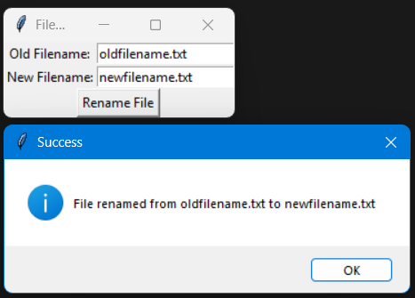

This is done in another window when the python code is run in an IDLE shell.

It open another window where we have to type out current filename correctly and a new filename that we want to rename it to.

It will then rename it successfully and the change is visible in real-time in the folder the file exists.

Voice User Interface:

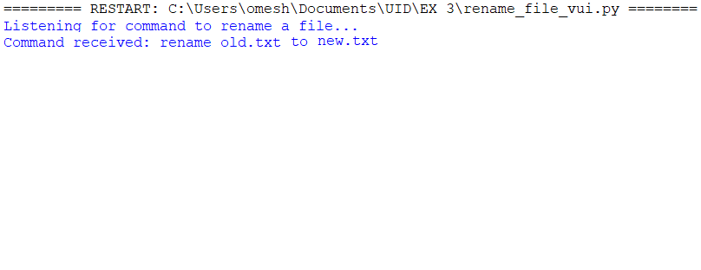

This is an interface that listens to the voice of the user and the command said is taken as input. Once the command is read the file name is renamed from the existing on to the desired file name.

It has certain constraints where “ . “ is read as “dot” or some times the filename itself does get read properly.

These issue can be avoided by training the voice input method to a higher level.